**The President’s Message**

Dear family and friends of Metro New York World Ministry let me take this opportunity to thank you for your encouraging words and support in prayer at the passing of our President, sister and friend, Tensie.

It was with much prayer, sorrow and anguish of soul, great heart-searching and a sense of my inadequacies to fulfill this unexpected responsibility, that I accepted the call to this position. But I was comforted with the fact that all God’s biddings are enabling and His Grace is sufficient. He promised never to leave me nor forsake me and His strength is made perfect in my weakness. Armed with these promises from the Captain of my salvation I moved forward in humility knowing that the best way that I could honor the memory of our President who was called to rest on January 25, 2013, is to take up the work where she left it and in the strength and power of the Holy spirit, carry it forward to completion. ‘There is no time to cease work. We must close up the ranks, seize the banner from the hand palsied by death and with renewed energy vindicate the truth and the honor of Christ’. (1T 111-112).

Another year of probationary time that had been granted us for labor has rolled into eternity. With the passing of time the end draws near. Many of the men and women, fellow travelers in life, with whom we have been associated, may have made decisions which will determine their future destiny. Question: How did you influence them? What efforts had you made to bring them to Christ? That which we failed to accomplish as Christians during the past year, **we cannot now do.** But with the help of the Holy Spirit we can redeem the time. Let us ask Him to deepen our love for and broaden our interest in the souls for whom Christ died.

We invite you to partner with us with your time, talent and your resources as we launch our 2014 initiative, **Preparing a People for the Second Coming of Jesus**. You are a vital link in the many arms of this ministry. May God bless you and thank you for remembering Metro New York World Ministry in your prayers and your giving.

In the Master’s Service

Allison Kerr



**Metro New York World Ministry 2013**

**A Solemn Responsibility Preparing a People for the 2nd Coming of Jesus**



**Coming again… coming again… Jesus is coming again…**

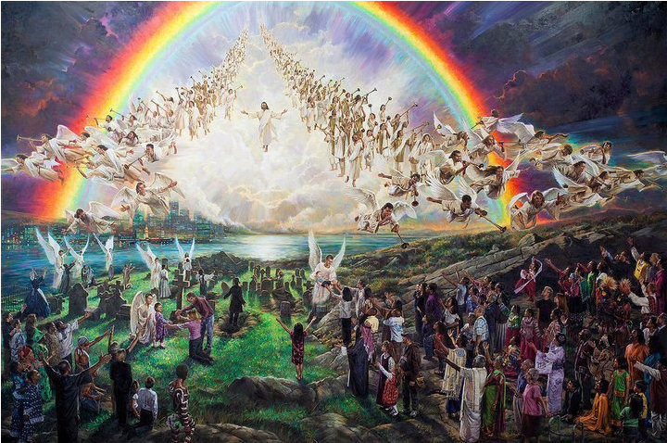

Tuesday, December 31st 2013 1:30 pm - 5:30 pm EST

**Broadcast line (218) 486-1622 Access code 13514#**

OR LIVE *via Internet Radio*

[www.metromenspm.com](http://www.metromenspm.com)

401-347-0388

**Metro New York Ministry 2013**

If the Bible is wrong and there is no God, those who have been faithful to what they believed would have lived a healthy & prosperous life… *with nothing to lose…*

**But, what if the Bible is exactly what it states and there is a Holy God, SOON to return**… will that person be in right standing *with Him*? Will His Son’s shed blood be accounted to the covering of those sins?

If you were expecting a special group of people for dinner… what would be *your* first steps?



If it was your job to train student scientists “*the absolute facts*” of the universe… what materials would you provide to give a clear cut lesson?

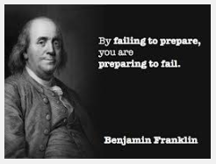

God has given *thorough* Instructions beginning in Genesis and ending in Revelation. He has provided a clear view of *the Great Controversy*. He has inspired pioneers both young & old to prepare a people for the time to come and as said by Benjamin Franklin “*by failing to prepare, you are preparing to fall.”*

**ARE YOU** **PREPARING** to meet The King? Are you the *faithful* Bride? **Titus 2:13 -** Looking for that blessed hope, and the glorious appearing of the great God and our Saviour Jesus Christ;

**Ready!** *Or not…* He is Coming Again - SOON!

*Welcome to the 2013 End of the Year Service*

**Metro New York World Ministry**

**December 31, 2013**

1:30 p.m. - 5:30 p.m. EST

**“God calls for men** who will prepare a people to stand in the great day of the Lord. As a people who believe in Christ’s soon coming, we have a message to bear, “*Prepare to meet thy God***.”**

**(CC: Chapter 266:3)**

**CALL TO WORSHIP**

**Prelude**

Organ Music

Chimes

Scripture Reading: 2 Peter 3:10-13…………………………………………….Pastor Dan Shafer

Call to worship:……………………………………………………………………………Pastor Dan Shafer

**Song: Hymn #671** …………………………………………………………………….Sister Donna Staple

Opening Prayer……………………………………..…………………………………....Pastor Dan Shafer

Song: Amen..……………….………………………………………………......................Bro. Roy Turner

**Welcome……………………….…………………….…………**Pastor Bowen/Bro. Danny Gordon

**Song:** **Hymn 212**…………………………………………………………….……...Brother Ron Turner

**WORSHIP IN REFLECTION**

Scripture Reading: Titus 2:13………………………………………………Pastor Isaac Olatunji

Prayer………………………………………………………………………………………..Pastor Isaac Olatunji

**Presentation: Reflections/Highlights 0f 2013………….**Pastor Cameron Bowen

In Remembrance :The Legacy of Sis Tensie*…………………….*.Pastor Gerzon Gomez

Song: So send I You……..…………………………………………..………………Sister Donna Staple

Testimonies of Thanksgiving ……….……………………………………...Elder Gene Nanton

**The Early Pioneers/The Vision.**……………...…...................Pastor Cameron Bowen

**Song:** Hymn #441….…………………………………………..…………………….Brother Roy Turner

***Legacy* :The Modern Standard Bearers**…..………………..……….Dr. Collin Standish

Prayer……………………………………………………………………………………………Dr. Collin Standish

**Song** :Hymn # 214……………………..................................................Brother Roy Turner



**WORSHIP IN STEWARDSHIP**

**“The Law of Life”**……………………….……………………….…………PastorWilliam Pergeson

Testimonies………………………………………….……………………………..………Elder Gene Nanton

Report: Missions & Projections……….……Pastor(s) Gomez/Bowen, Elder Cross

Thanksgiving Offering & Prayer of Gratitude………………..…. Pastor Jeff Wehr

Song:We Give Thee but Thine Own……………………………………. Donna Staple

**WORSHIP IN PROCLAMATION**

Metro Kids…………………………………………………………Aunty Laureen, Jadon & Jon Jon

*Jesus Loves the little ones like me, me, me*…………………………………………………….Roy Turner

*Uncle Darryl’s* Story Time……………………………………………………………………Uncle Darryl

Scripture Reading: John 15:5……………………………………………..………… Pastor Olatunji

**“Fill it up and Check the Oil”**………………………………………………...Pastor Dan Shafer

**WORSHIP IN CONSECRATION/DEDICATION**

*Qualified by the Holy Spirit to Proclaim the Second Coming of Christ*

C:\Users\The Russell Family\AppData\Local\Microsoft\Windows\Temporary Internet Files\Content.IE5\2KEV32DT\MC900150607[1].wmf**Think it through** What was the reason for the rapid spread of the gospel in Apostolic times? Was it due to the educational attainments, the financial resources, and administrative skills of the early Christians, **or** was *it the result of their willingness to be directed by the Holy Spirit*?

**Answer:** ‘Your energy and efficiency in the up building of My kingdom, Jesus says, depends upon your receiving of My Spirit. You must be partakers of My grace, in order to be a savor of life unto life’. (DA 439)

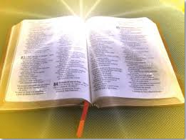*…This Gospel shall be preached in all the world...*

**Call to light the Lamps and Candles**

*Prayerfully Read & Sign the Pledge of Commitment*



**L**oving Heavenly Father, knowing and understanding that I can do all things through Christ by the Personal in-dwelling Presence and Power of the Holy Spirit,

I , promise to take an active part in the proclamation of the 3rd Angel’s Message using my time, talents and resources in ceaseless labor in the service of others, to extend and finish the work of the gospel in all the world and then shall the end come.

Signature Date / /

Prayers of Dedication and Consecration …………………Pastors Shafer & Standish

Song: Go Ye Therefore And Teach All Nations……………………………………..Recorded

Vote of Thanks from the Chairman/benediction………Pastor Cameron Bowen

Closing Song:……………………………………………………………………………..……Bro Roy Turner.



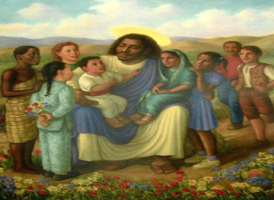

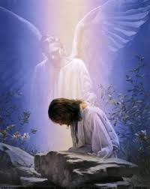**Rescuing Ruben**

*By Olevia Senior*

On Wednesday, October 30, 2013, I received a text from my eldest sister who resides in Panama saying, “*Pray please*!" My nephew *Ruben* had been abducted and kidnappers wanted a hundred thousand dollars as a ransom.

Immediately I began to pray. For years now, I’ve been listening to **Metro New York World Ministry**. Every lesson taught in *Patriarchs and Prophets* made me realize and understand how *faithful* God is to His People! Unchanging and ever powerful... the God of the impossible, and because this truth anchored, I was able to quickly relate this confidently to my sister Clara. I knew that God was in control and she had to trust and believe.

The following day, the abductors called, demanding money or else Ruben would be sent, in pieces, in a plastic bag. They said my sister was not to seek help from the authorities, or she would never see her son again. Our only hope is in God.

My sister’s pastor said, “the life of your son is neither in your hands, nor in the hands of the abductors, but it’s in the hand of God!" When the kidnappers call again, tell them they’ve picked on the people of God; therefore, they are messing with God Himself! **Silence was at the other end of the phone**…

The Metro New York Prayer Task Force, retired pastors in New York, and my church family, prayed for the deliverance and safety of Ruben. My sister in Georgia and my brother in Korea fasted and prayed along with others. Early Sunday morning at 3:30 a.m., my sister sent a message to me. Ruben has been freed and was brought home safely. My heart is overwhelmed with joy and gratefulness to see God’s great mercy. My prayer is that this testimony will touch the lives of many people and encourage them to always trust in God; for He cares *for His children*. No other power can overcome evil, but the power of righteousness which is the power of God Himself.

**Healed By Faith**

*By Shauna Carty*

**"Beautiful. Beautiful. Jesus is so beautiful. Jesus makes beautiful things of my life."**

Annie sang into the microphone praising God with all her heart, soul, mind, and strength. The song is also her testimony, only one month after doctors wanted to perform emergency surgery to remove a palm sized portion of Annie's skull. Why? They thought she had either cancer, or some other illness, that could spread to her brain if they didn't remove it immediately, but they wouldn't know for sure until they removed the damaged tissue and tested it.

It was a miracle that Annie's parents didn't listen to these doctors whom they trusted because they had been taking care of the twelve-year-old girl for years. Instead, the Lord called them to wait on Him and seek His face for an alternative.

Shortly after receiving the bad news, Annie's cousin put her family in touch with Metro New York World Ministry. Dr. Zeno and Dr. Kerr from the ministry reviewed Annie's medical records and said, "*No. Do not do this surgery*." Dr. Zeno and Dr. Kerr explained that the illness they thought Annie had could be treated without surgery and said the surgery would unnecessarily disfigure our child.

After much prayer and fasting by Annie's family, the Metro New York Prayer Task Force, and prayer warriors around the world who had heard Annie's story, the ministry directed Annie's family to Dr. Polly Ferguson, a specialist at the University of Iowa Children's Hospital. Dr. Ferguson treated her for CRMO, an illness which causes bone pain but generally stops completely once a child stops growing.

**Today, Annie stands *miraculously* healed.** The illness which had her sick in bed and unable to function normally is now a testimony of God's miraculous healing power. She laughs playfully, the wind blowing her hair back, as she races with her brother and two sisters around the track. She sings and dances her praise unto the Lord Jesus.

"And the prayer of faith will save the sick, and the Lord will raise Him up. And if he has committed sins, he will be forgiven." James 5:15

 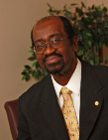**Another Year**

*Cameron A. Bowen,*

**Chairman**

One more year has ended, and God has yet been merciful to us. He has provided, and guided, in ways that only He can. Carefully, he has taught us, encouraged and nurtured us. The challenges of the past have dwindled away, the victories that we have won, through His strength, stand as a testimony of His overcoming power. Whether we know it or not, God has preserved us for a reason, is teaching us, for a reason, transforming our minds, for a reason. That which he has given, and continues to give, is intended to be shared with those who have not yet begun their walk with Him. So while we can truly consider ourselves privileged to see the end of another year, let us be aware of the awesome privilege of being called to serve.

This is indeed a time for reflection, for introspection. How have we used that which we have been given? Have we grown? What is our focus? Do those who know us best, see in us the change that comes because of all that we have gained? Is there an inner calm, an inner peace that comes from our walk with our Redeemer? These questions cannot be answered in a moment. As I said before, these questions demand introspection, a prayerful look within. For growth is a necessary process. Like the tender plant which daily develops within, with no visible evidence without, we too must grow within, if we are ever to be a witness to that growth, without. Listen to what The Great Controversy says about what is expected of us.



“Our responsibility is greater than was that of our ancestors. We are accountable for the light which they received, and which was handed down as an inheritance for us, and we are accountable also for the additional light which is now shining upon us from the Word of God***.” {GC88 164.2}***

So let us be thankful for all that we have received, but let this be clear; these gifts, these privileges, demand our complete surrender. For all that we have been given will be of little or no value to us, except we be transformed in the likeness of God’s image, and diligently share with others the light we have received. May God continue to be with you, and continue to bless.



**The Growth of a Ministry**

*grounded & rooted in Christ*

During the year 2013 the Ministry has seen the hand of the Lord leading it along a path where we are able to reach thousands even millions with the gospel and they now have the opportunity to hear the three angel messages and be saved in the Kingdom.

We have seen God move his servants around and brought into the technical department changes which has resulted in the development of, at first a fledgling internet radio, but with the acquisition of new equipment it has now blossomed into a sound of peace, rejoicing and a megaphone for the undiluted messages to go forth throughout the world drawing our brothers and sisters all over the world into a new awakening to the knowledge of our Lord and Savior. We have also and still developing a new website which will offer upgraded archives and health section, children’s and youth corner.

There are many programs that can be heard on the internet radio including the powerful Sermons by Dr. Frezee, the cooking classes, Metro kids every Sabbath morning, the rebroadcast of the daily morning service and the beautiful uplifting spiritual music that takes you to the throne of God. The internet radio can now be heard also 24 hours a day by calling 401-347-0388 anytime.

The words of our Lord and Savior says, ‘Again I say unto you, That if two of you shall agree on earth as touching anything that they shall ask, it shall be done for them of my Father which is in heaven’. Matthew 18:19. With these words in mind the Holy Spirit inspired the formation the Metro New York World Prayer Taskforce. A special group of dedicated brothers and sisters with a burden for souls coming together numerous times a day, throughout the week to intercede on behalf of thousands of listeners around the world and prayers have been answered.

We have heard that in the last days ‘that soon there will be no work done in ministerial lines but medical missionary work’ (CH 533:2) Until we no longer have religious liberty we are preparing a people through our Metro Medical Missionary College which is free to all and they will be equipped with the ‘entering wedge’ and armed with the Word. It is an intense and very thorough program airing live on Friday evenings at 7pm EST.

Our Heavenly Father through the power of the Holy Spirit is moving swiftly, taking this Ministry to unreached territories and fields to get the gospel out and hasten the Second Coming of Christ. Please join us and, pray with us as we watch our heavenly Father lead, guide and direct His Ministry.